**CSE307 Sec03**

**Assignment-3**



**Department of CSE , Spring 2024**

**Independent University, Bangladesh (IUB)**

**Submitted to Submitted by**

|  |  |
| --- | --- |
| **Sabrina Alam**  **Lecturer,**  **School of Engineering, Technology and Sciences, Independent University Bangladesh (IUB)** | **Sumaiya Jannat**  **ID: 1730469** |
| **Kaushik Dey Joy**  **ID: 1821818** |
| **Jahid Hasan Milon ID: 1930666** |
| **Abir Hossain Sangram**  **ID: 2022734** |
|

Contents

1. Entity-Relationship Diagram (ERD) 3

2. Logical Data Flow Diagram of Whole System 4

1. Physical Data Flow Diagram 7

6.Communication Diagram 19

7. Class Diagram 22

### 1. Entity-Relationship Diagram (ERD)



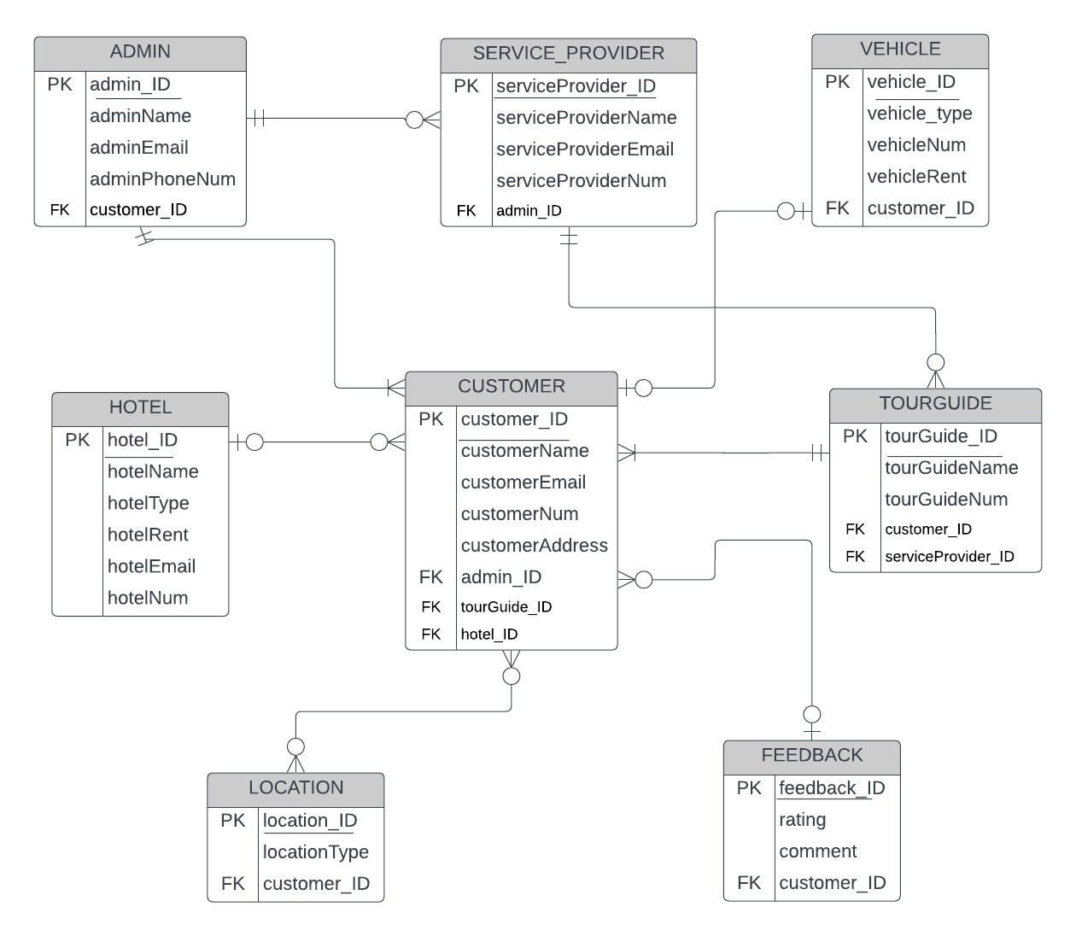

### 2. Logical Data Flow Diagram of Whole System

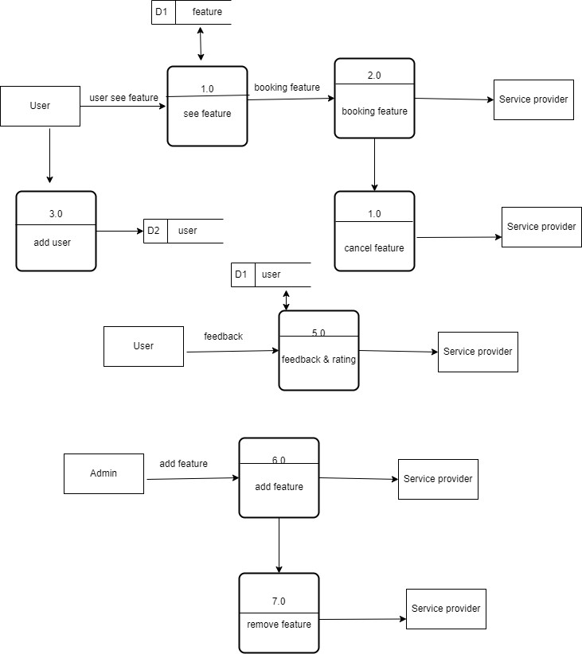

2.1 Logical Data Flow Diagram of “Hotel Booking”

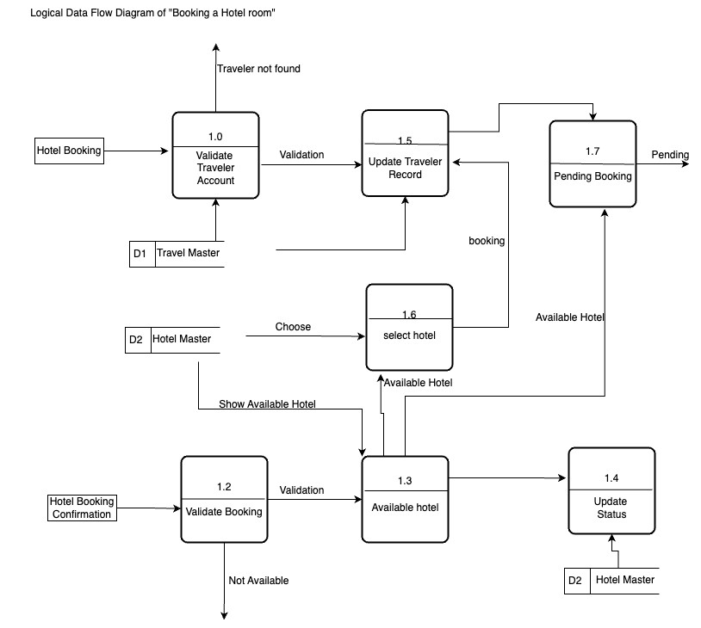

2.2 Logical Data Flow Diagram of “Packages”

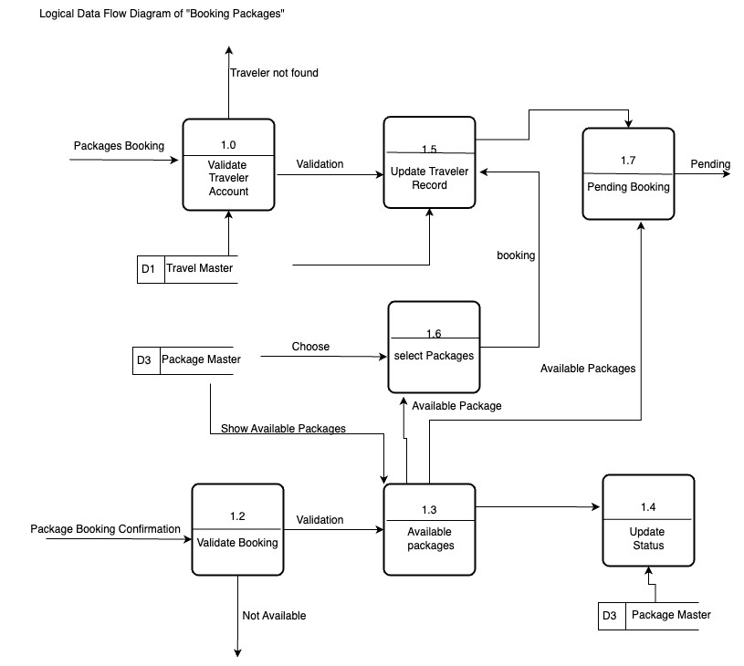

2.3 Logical Data Flow Diagram of “Translation”



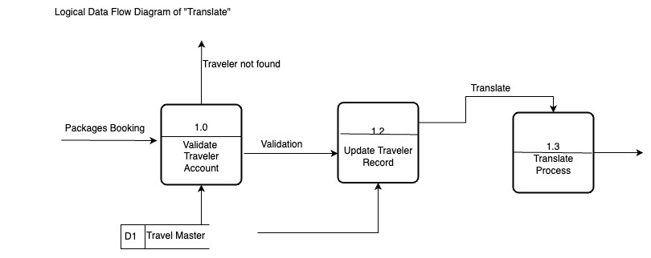

## Physical Data Flow Diagram

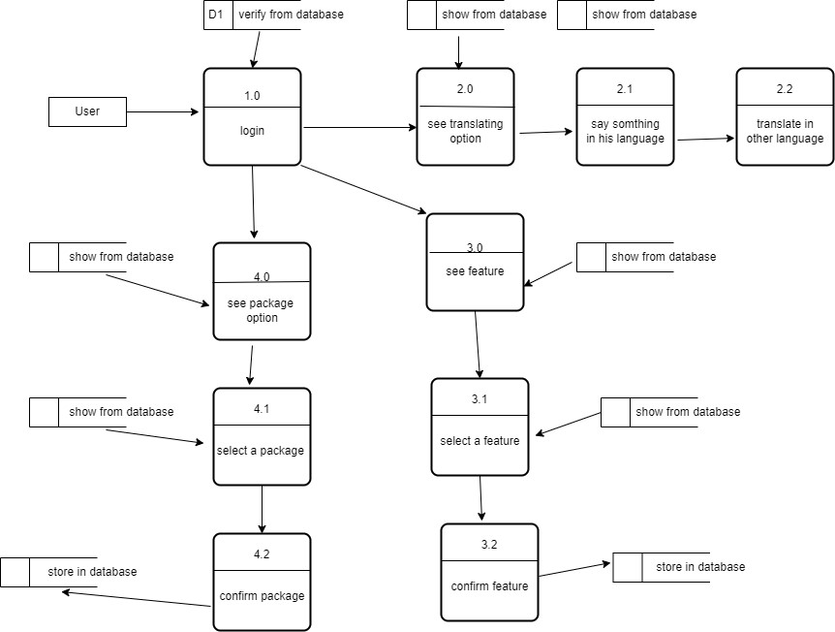

 3.1Physical Data Flow Diagram for “Booking a Hotel room”

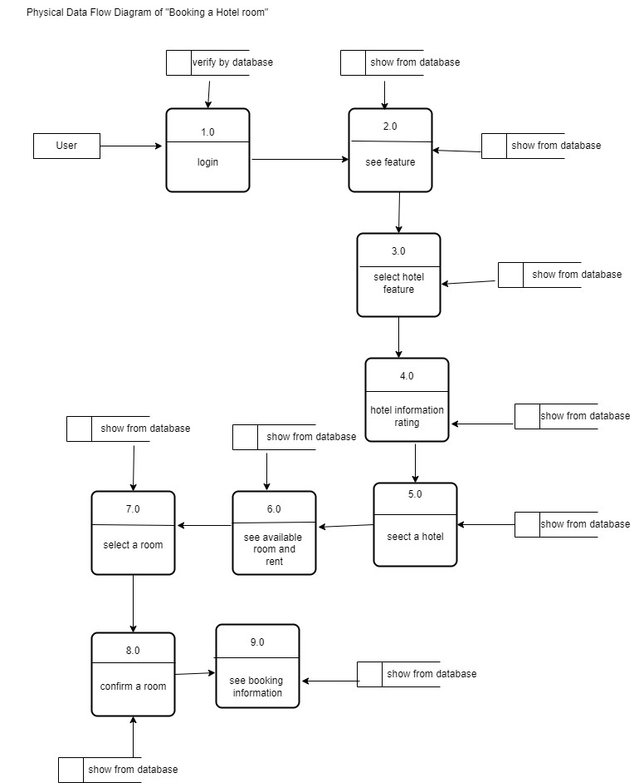

 3.2. Physical Data Flow Diagram for “Packages”

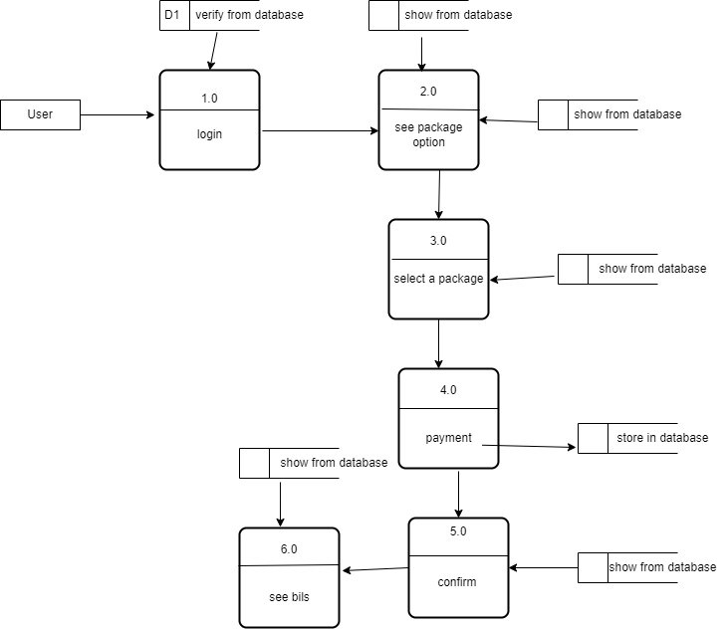

3.3Physical Data Flow Diagram for “Translate”

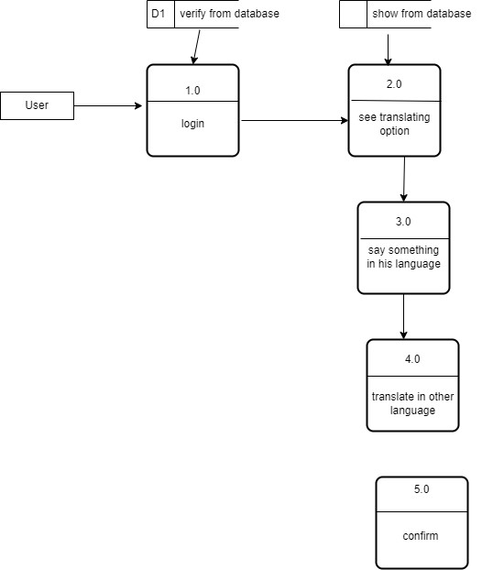

1. Activity Diagram

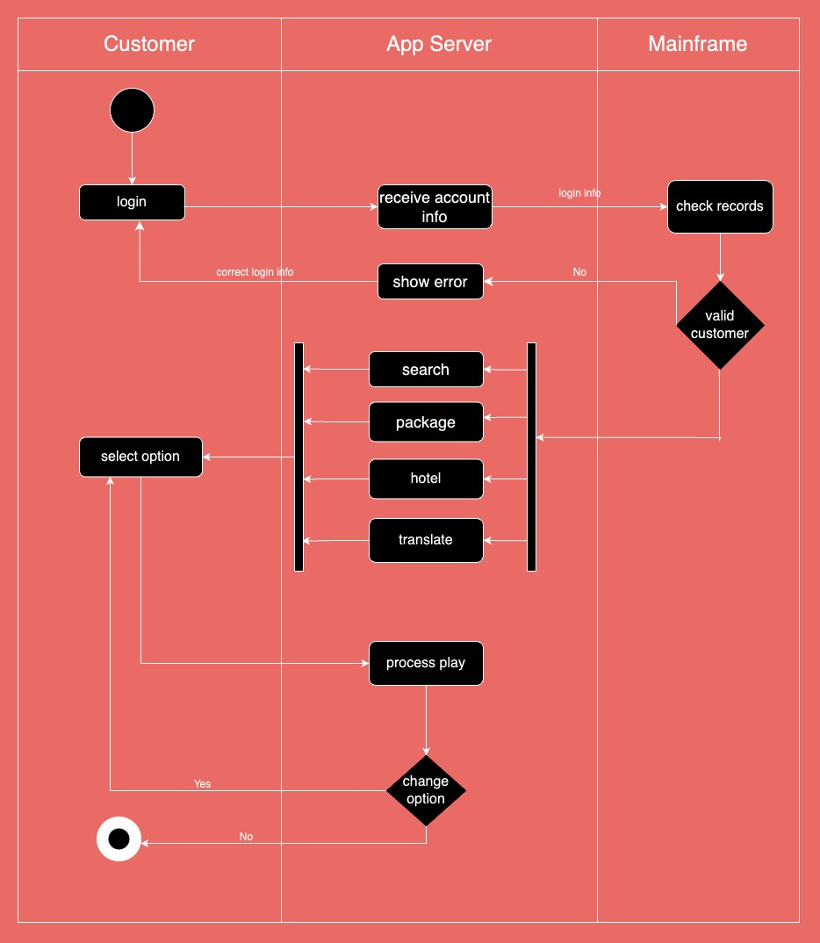



4.1

Activity Diagram for “Hotel Booking”

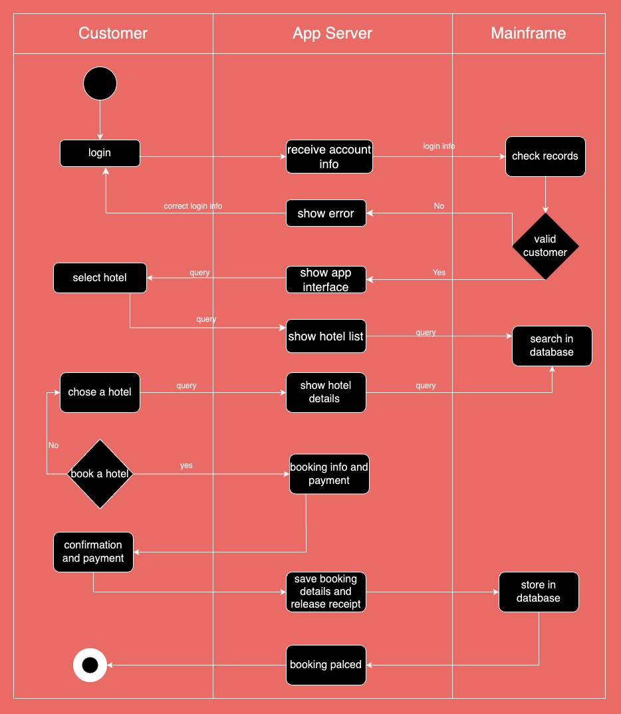

4.2

Activity Diagram for “Package”

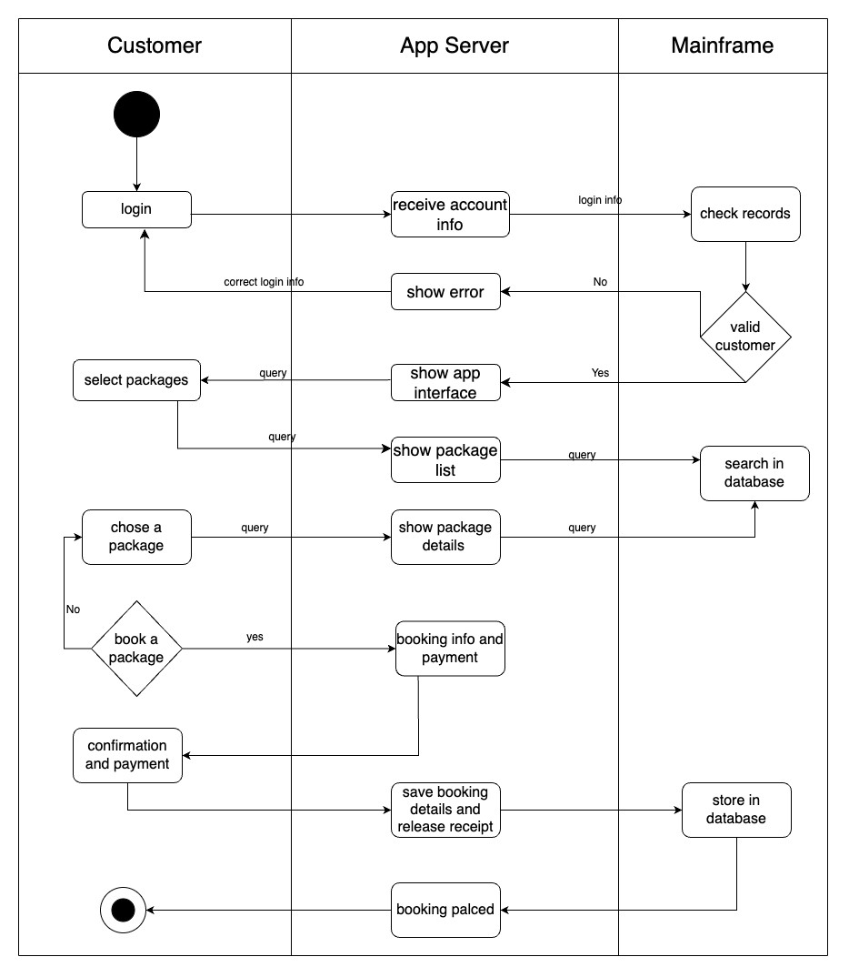

4.3 Activity Diagram for “Package”

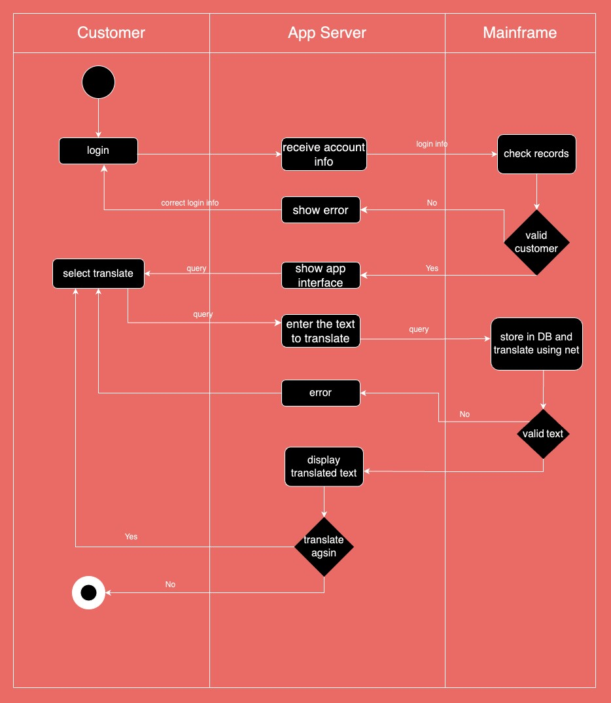

1. Sequence Diagram

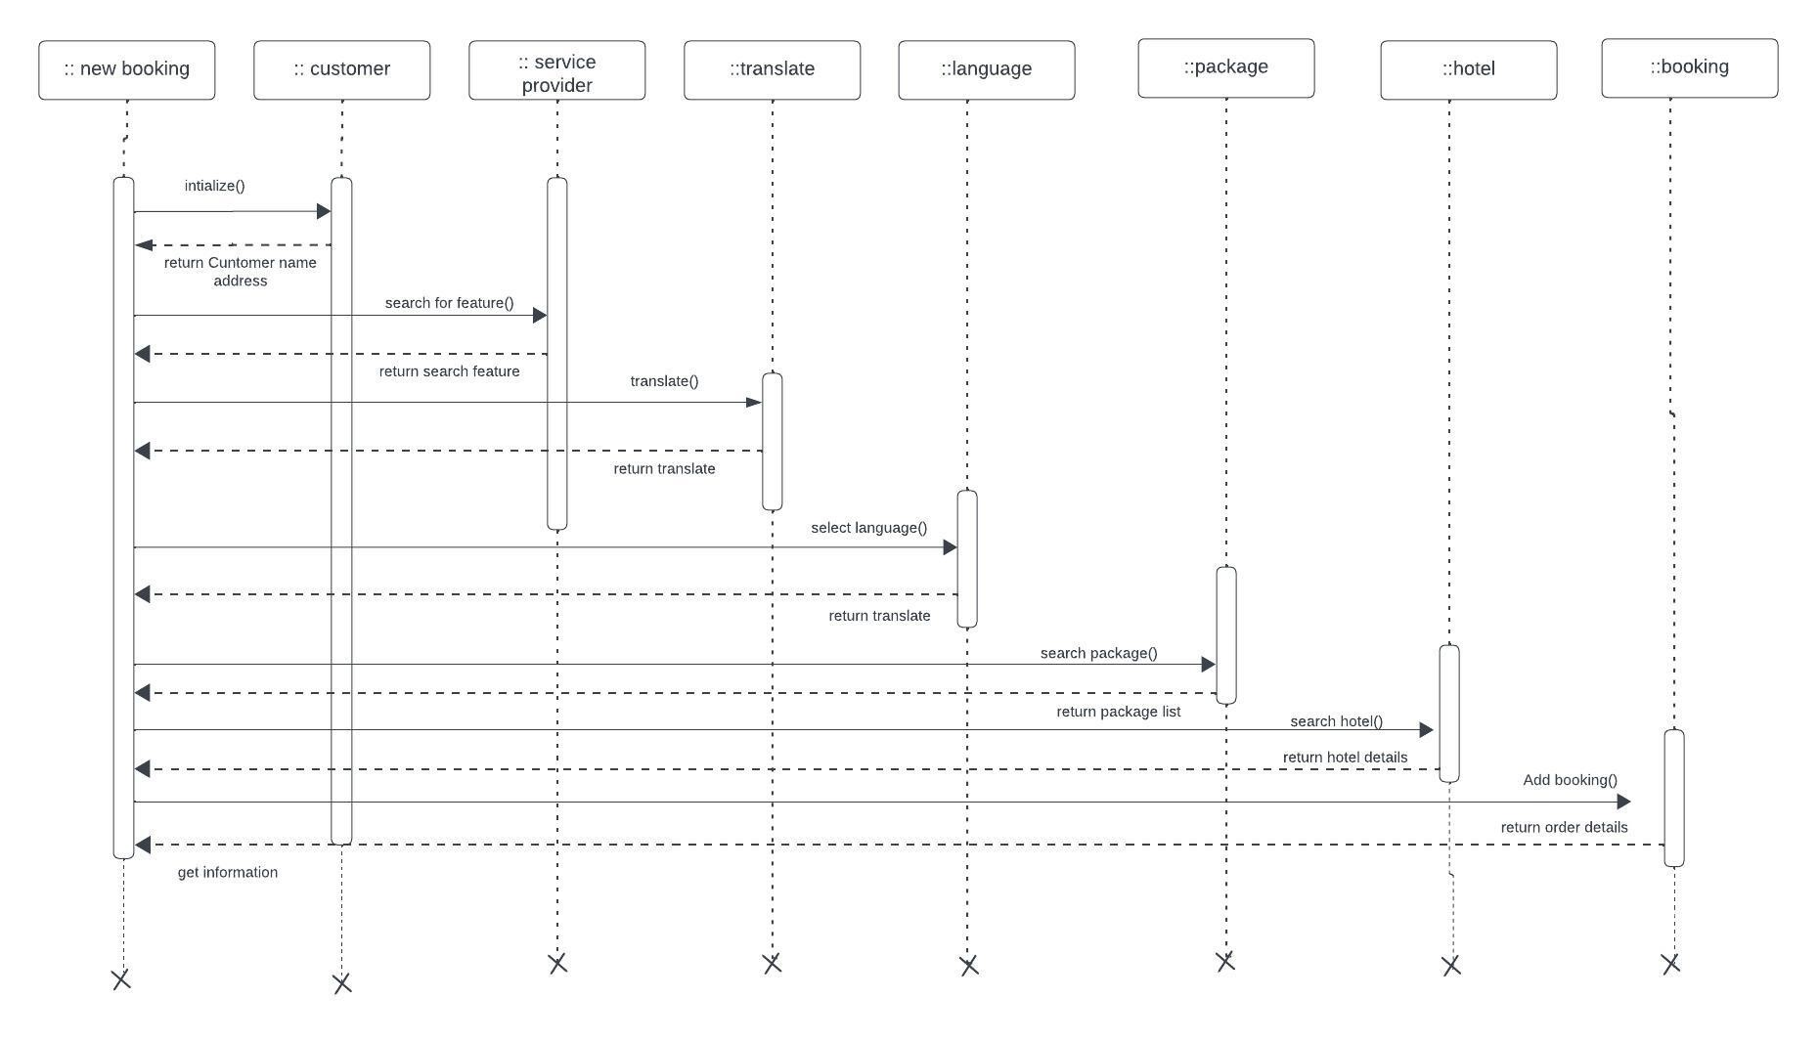

* 1. Sequence Diagram for “Booking a hotel”

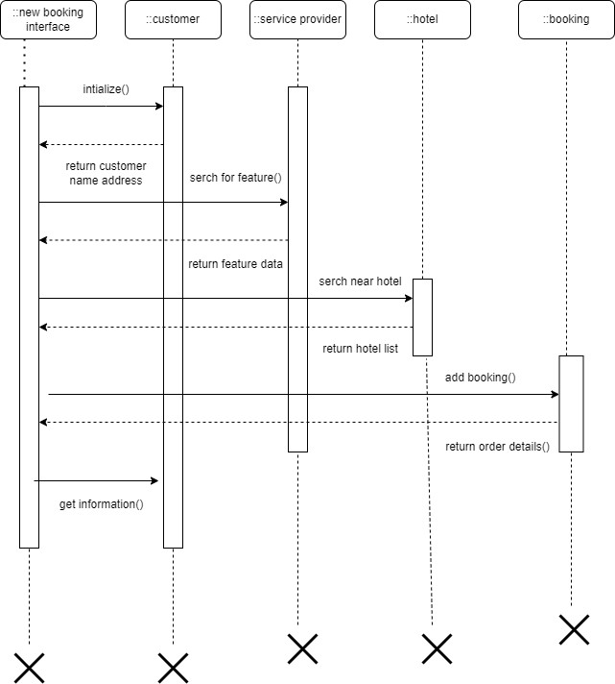

* 1. Sequence Diagram for “Packages”

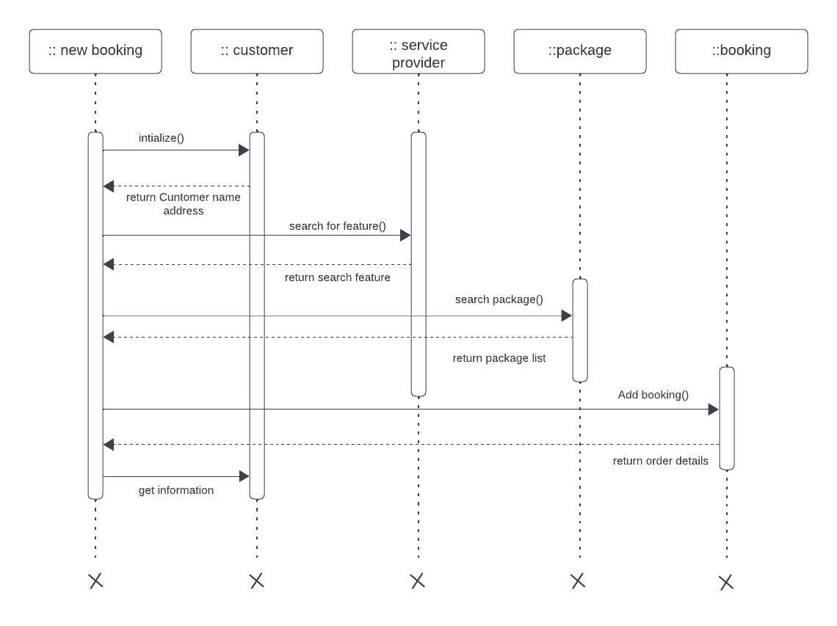

* 1. Sequence Diagram for “Translate”

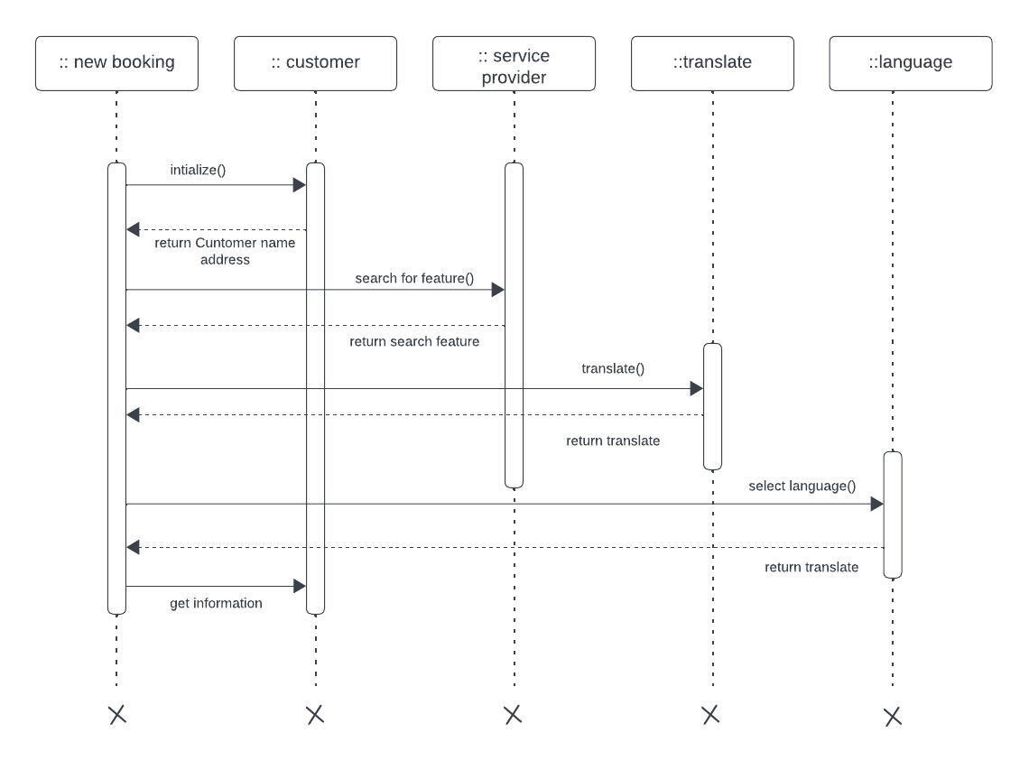

# 6.Communication Diagram

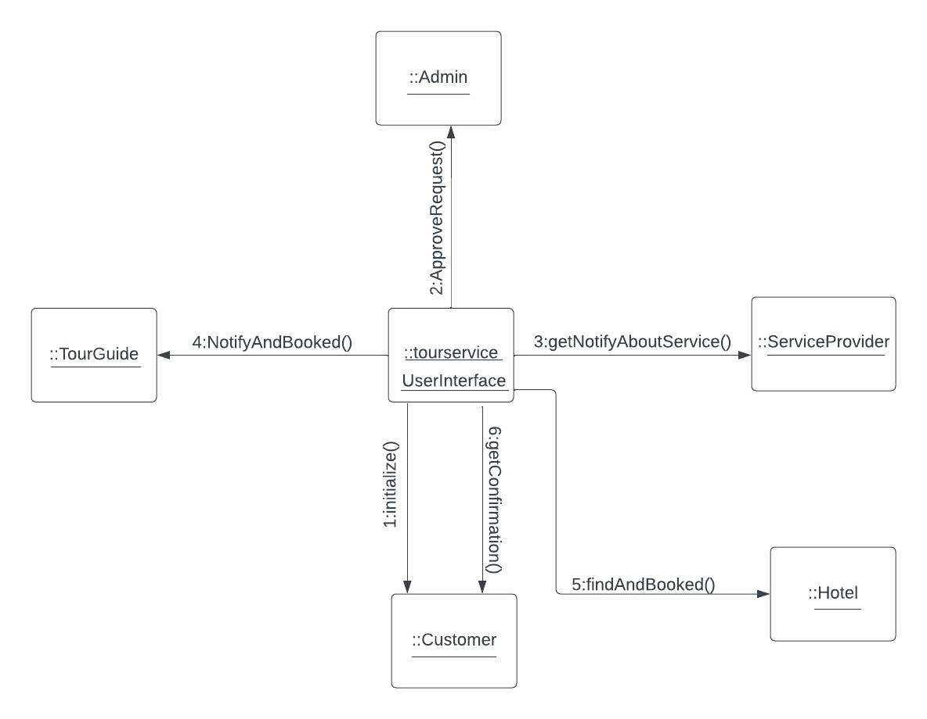

6.1 Communication Diagram for "Booking Hotel”



6.2 Communication Diagram for "Packages”

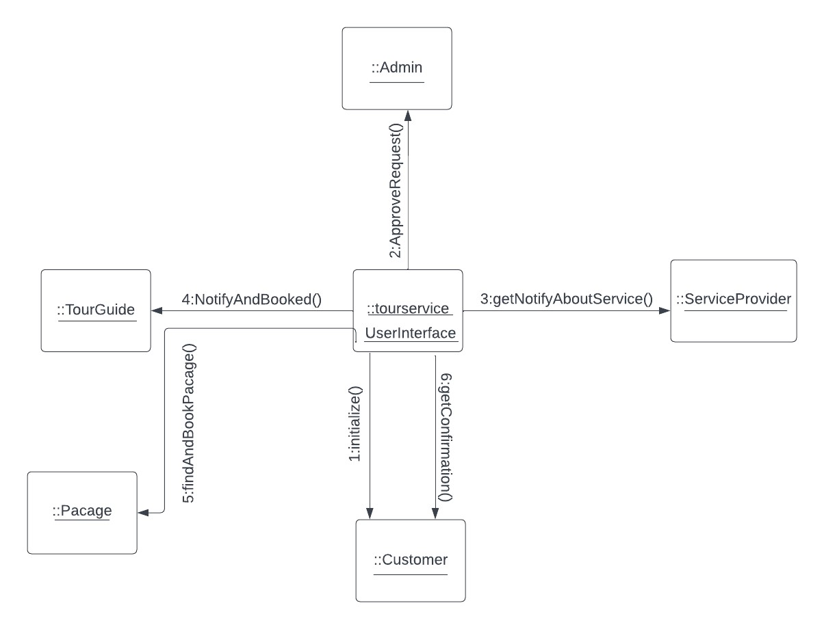

6.3 Communication Diagram for "Translate”

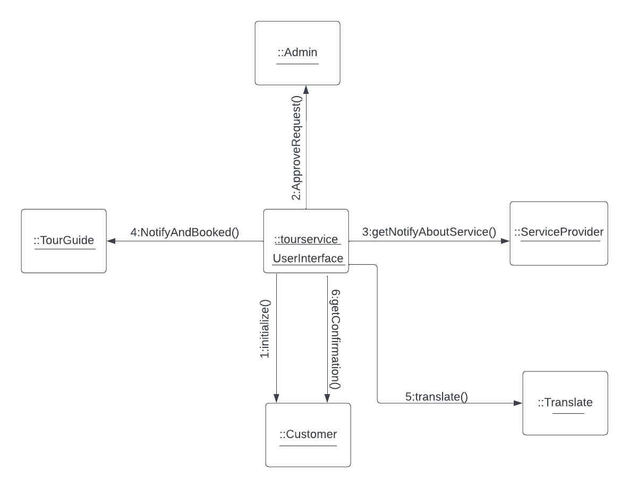

# 7. Class Diagram

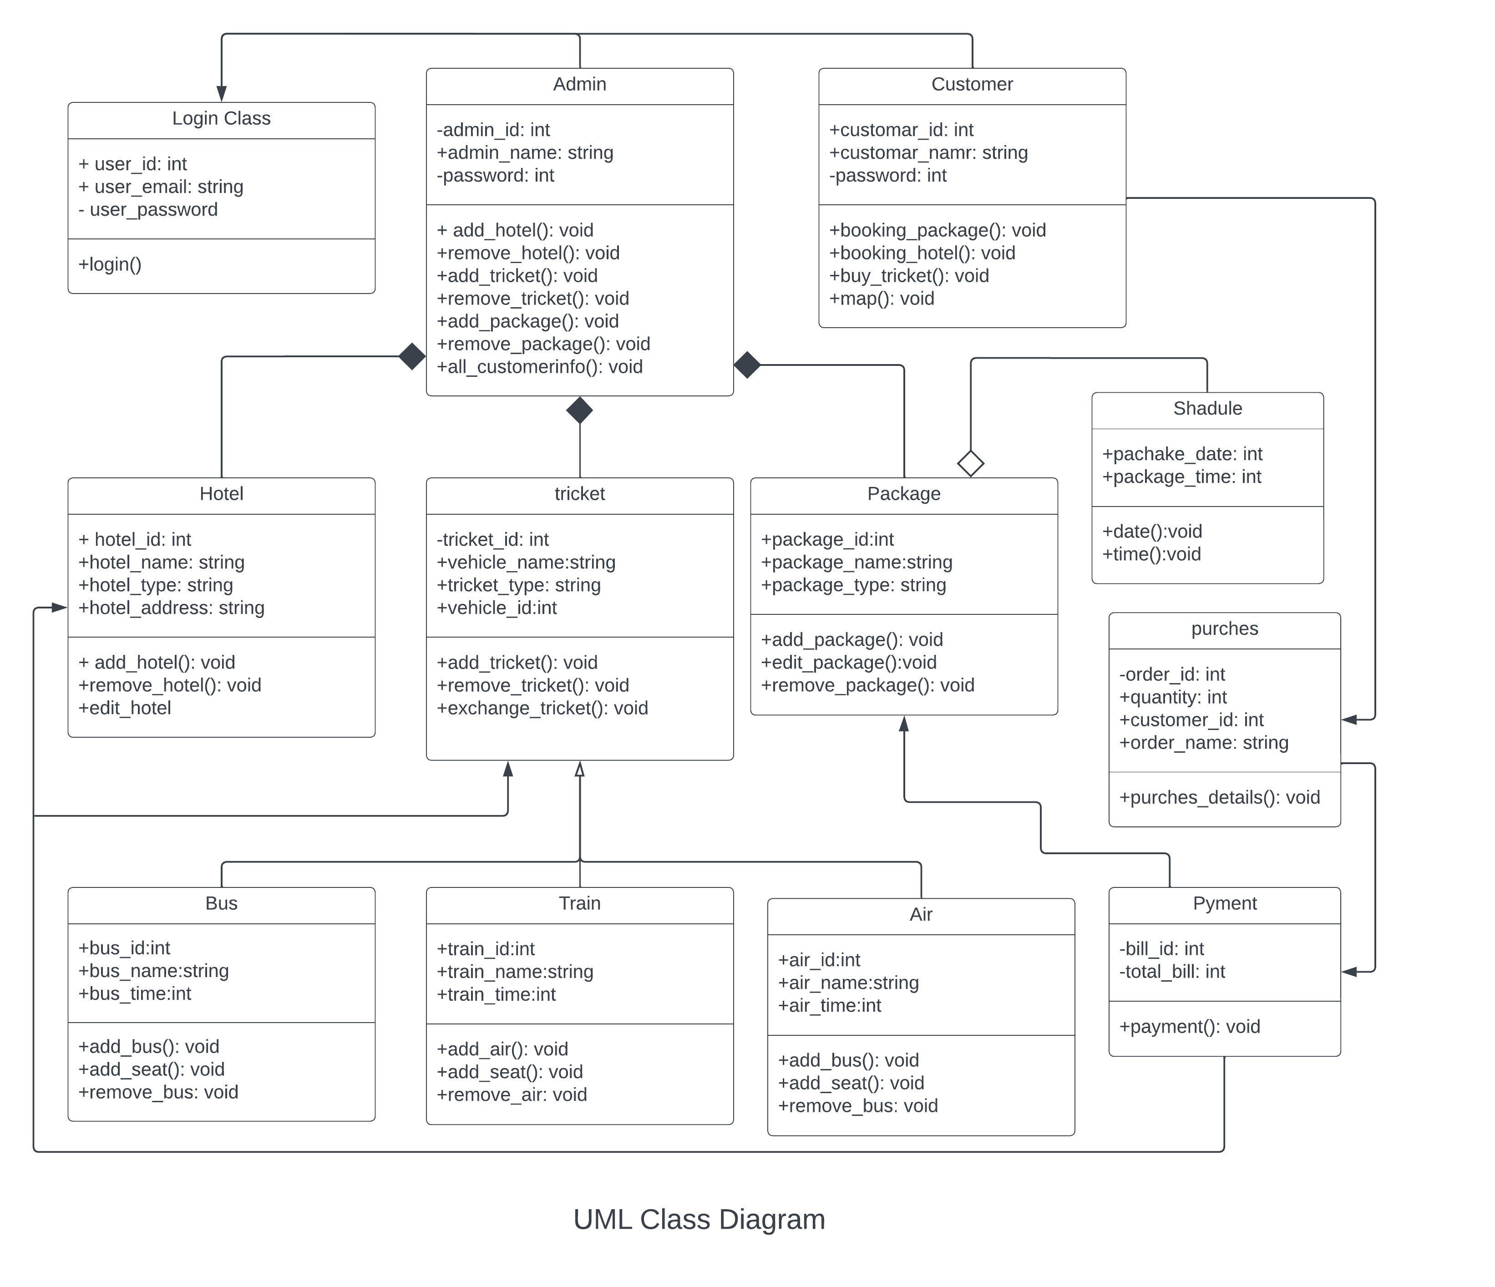

1. State chart Diagrams

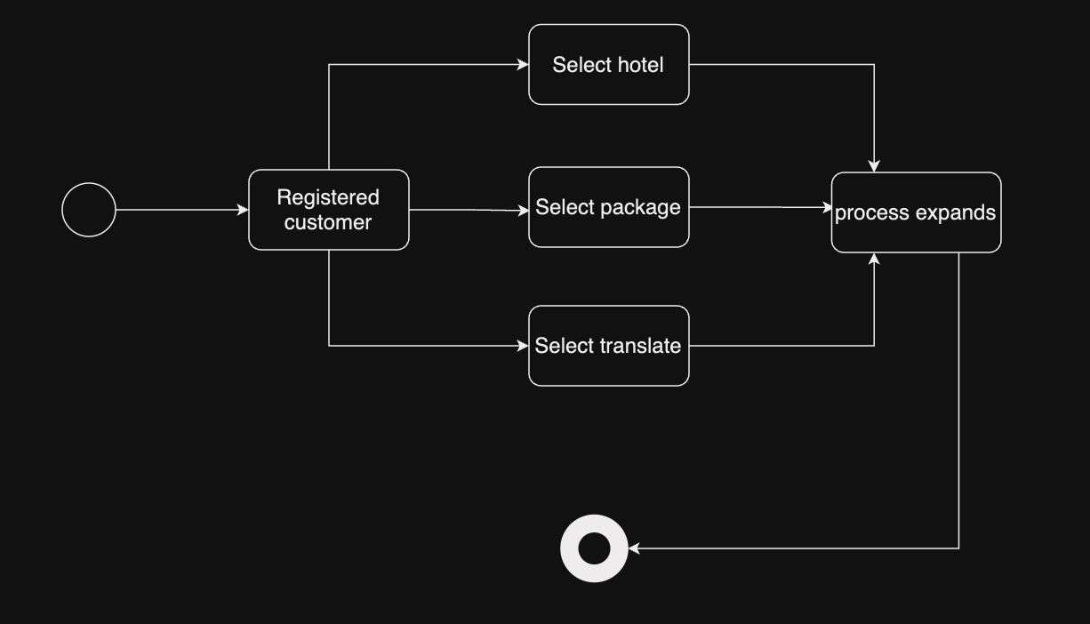

* 1. State chart Diagrams For “Booking Hotel”

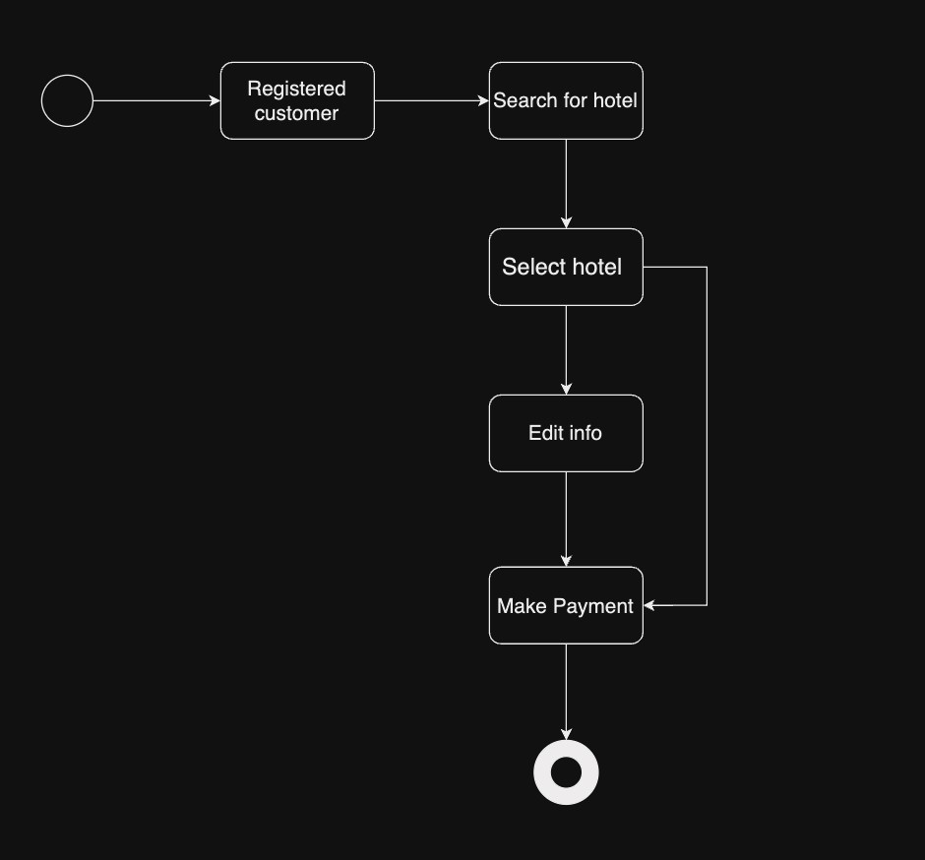

* 1. State chart Diagrams For “packages”

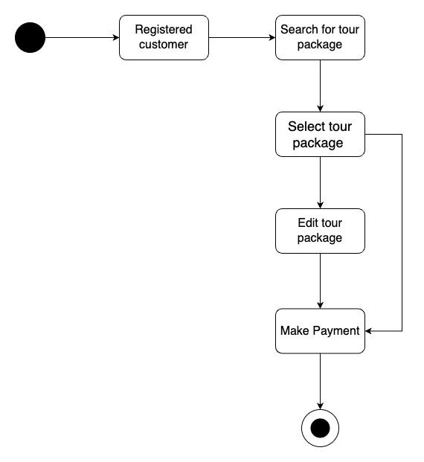

8.2 State chart Diagrams For “Translate”

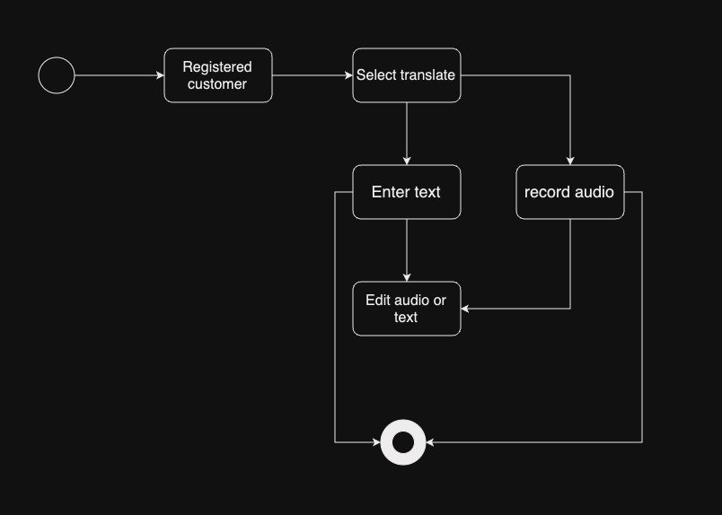

9. CRUD Matrix

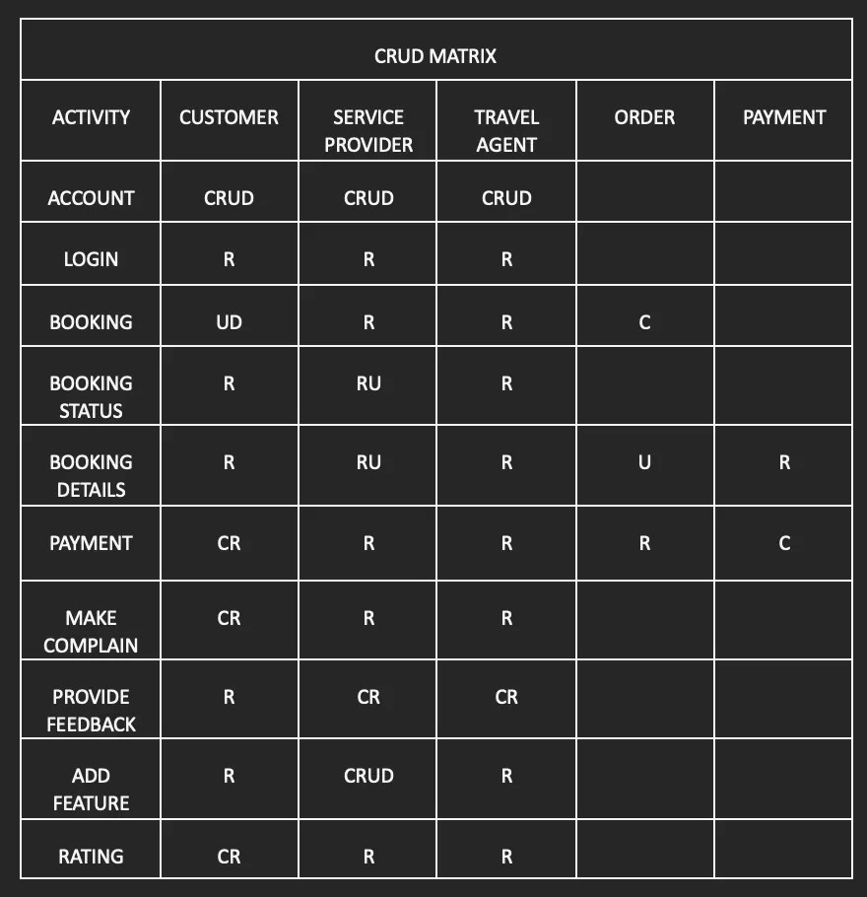

P a g e 29 |